Goal

* Pick user requirements we want to evaluate with quantitative user evaluation
  + \textbf{User Requirement 1}: When entering text on mobile devices, user should not make more typos (slips) when operating with one hand compared to operating with both hands (U05-07, U5-08, U05-13, U05-23, U05-27, U05-29, U05-35, U01-14, U01-15, U03-04).
  + \textbf{**User Requirement 5**}: User should be able to locate and enter emojis, punctuations, and numbers on the mobile device with one hand faster than their default (i.e., current or existing) method of entry (U05-15, U05-16, U05-17, U05-37, U04-09, U04-18, U02-08, U03-06, U03-18, U03-19).
* Build high-fidelity, functional prototype **(finish before Friday)**
  + Identify which features we need to implement in order to evaluate the user requirements
    - Normal keyboard (on their phone) (good)
    - Shift keyboard
      * look for functional keyboards online
      * 2 Punctuation keys
      * Emojis key
      * Numbers key
    - Emojis keyboard
    - Numbers keyboard
* Identify study design
  + counterbalance which participant start with which keyboard
    - participant 1: my design, then the current design
    - participant 2: the current design, my design
    - alternate…
  + 3 individual tests - 2 sessions per keyboard (randomly choose the first keyboard to use)
    - Randomize the 12 tests, but keep the keyboard constant within the 12 tests for the 2 sessions
    - One for punctuation
      * hello,
      * hello.
      * hello?
      * hello!
    - One for emojis
      * world,
      * world.
      * world?
      * world!
    - One for numbers
      * Foobar37
      * Foobar42
      * Foobar10
      * Foobar96
  + IVs
    - Keyboard Design
      * (we just use the last session)
      * if we do sessions, GSI said we need to analyze data for each session and then also include overall analysis of data of all sessions
        + he mentioned something about sessions in lecture and said we can check that
  + DVs
    - Time for Punctuation
    - Time for Emoji
    - Time for Numbers
  + Statistical Analysis to use
    - 3 separate Paired t tests
      * this is ok
    - Assume normality because mean typing speed is normally distributed
      * this is ok
  + Number of participants needed
    - G*power
    - 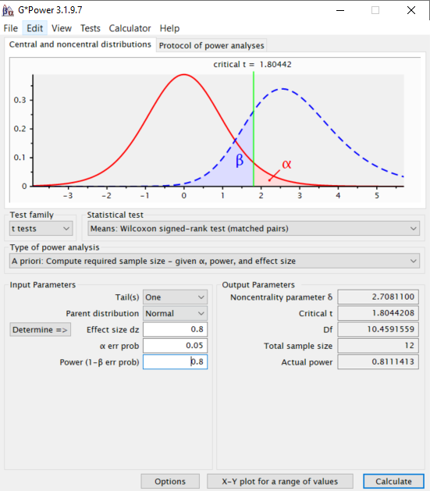
    - Need at least 12 participants
    - 12 – 20 participants
      * this is ok
    - Each member find 3 participants
    - Need to mention how we arrived at the number of participants: just say we used g*power with the above parameters in the screenshot
  + How does this study design address your requirements